Technical Document

The below said software’s and its related versions are installed:

1. Java - java 17.0.9

Java(TM) SE Runtime Environment (build 17.0.9+11-LTS-201)

Java HotSpot(TM) 64-Bit Server VM (build 17.0.9+11-LTS-201, mixed mode, sharing)

1. We can download eclipse for J2EE web applications with latest versions like 2023.
2. Eclipse IDE for Enterprise Java and Web Developers (includes Incubating components)

Version: 2023-09 (4.29.0)

Build id: 20230907-1323

1. Apache Maven 3.9.5

Maven home: C:\Program Files\apache-maven-3.9.5-bin\apache-maven-3.9.5

Java version: 17.0.9, vendor: Oracle Corporation, runtime: C:\Program Files\Java\jdk-17

Default locale: en_IN, platform encoding: Cp1252

OS name: "windows 11", version: "10.0", arch: "amd64", family: "windows"

1. Apache Tomcat Version 10.0.1.
2. MySQL DB – MySQL Workbench version 8.0.34
3. Oracle 10g.

* Download Java 17 version for windows:



Please refer the above pdf for downloading Java17 for both MAC & Windows.

* **Step by Step Implementation**

1. Download and install JDK (optional if java is not installed on the machine)
2. install Eclipse IDE
3. Open the downloaded file and select ‘*Eclipse IDE For Enterprise Java and Web Developers’* from the pop-up*.*
4. Choose the installation folder and press the ‘*INSTALL’* button.
5. Lastly, click on the ‘*LAUNCH’*button.

**Step 1:** Download and install JDK

To run Eclipse on your workspace first you need to download and install JDK  (Java Development Kit). Open your default browser and search for ‘JDK download’ and click on the link of oracle.com. Oracle provides you latest version of JDK. You can download from here according to your required configuration. Please refer to this article [How to Download and Install Java for the 64-bit machine](https://www.geeksforgeeks.org/how-to-download-and-install-java-for-64-bit-machine/) and install the JDK in your system.

**Step 2:** After installing JDK on your workspace, we can install Eclipse IDE by [downloading Eclipse IDE](https://www.eclipse.org/downloads/).

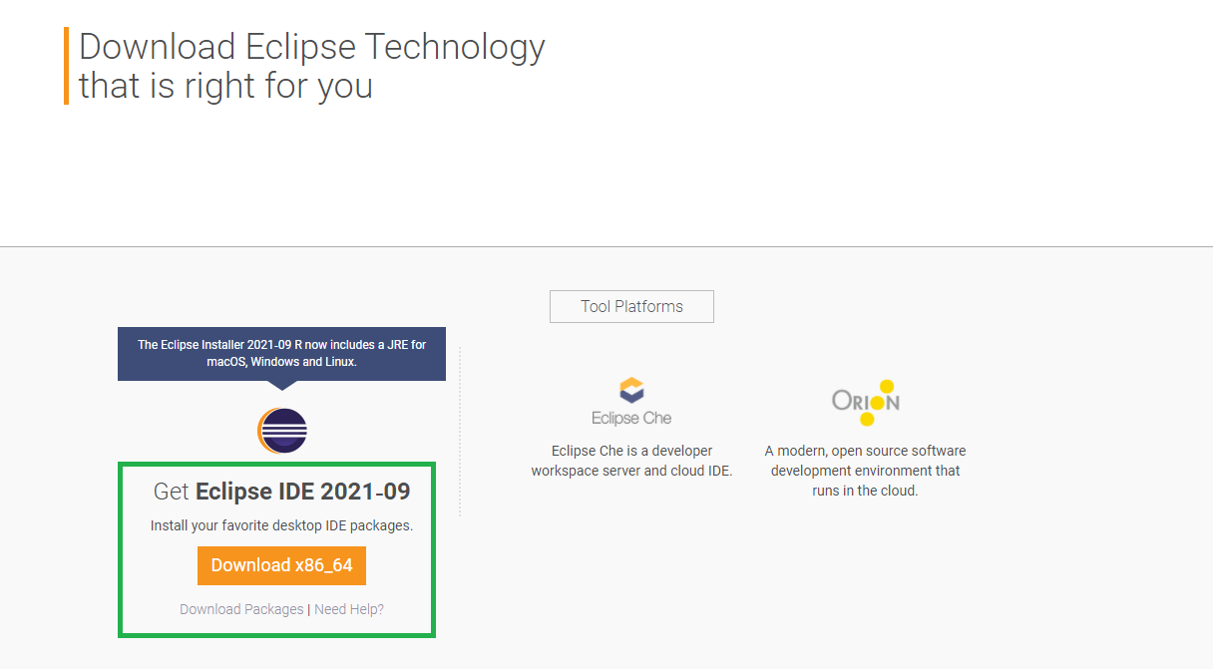

**Step 3:** After downloading, open the downloaded file and choose **Run** from the pop-up window opened on your screen. Now from the below page select the second option named *‘Eclipse IDE For Enterprise Java and Web Developers.’*

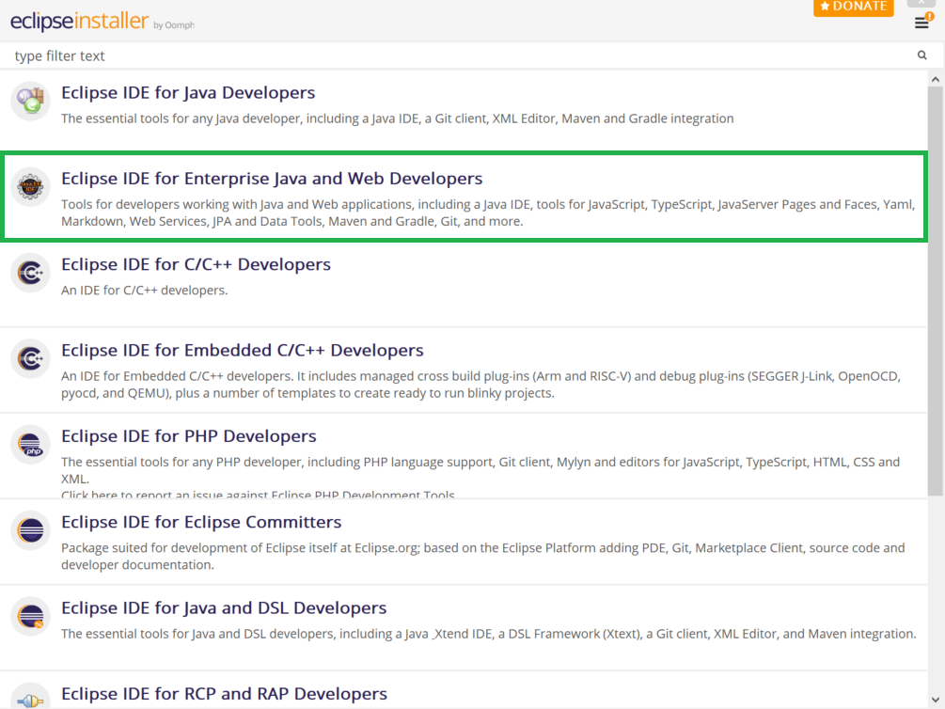

**Step 4:** After clicking on this the below screen will appear. Now click on the **Install** button. By accepting the Agreement you can complete installation. It will take some time to complete the installation.

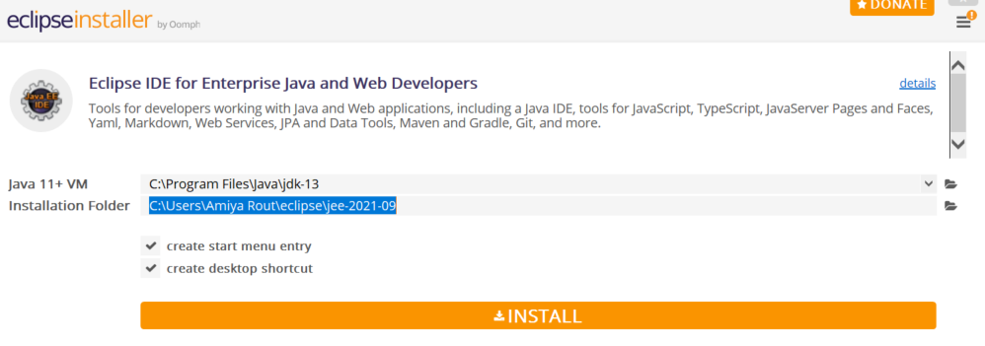

**Step 5:** After successfully installed now click on the **LAUNCH** button as shown below.

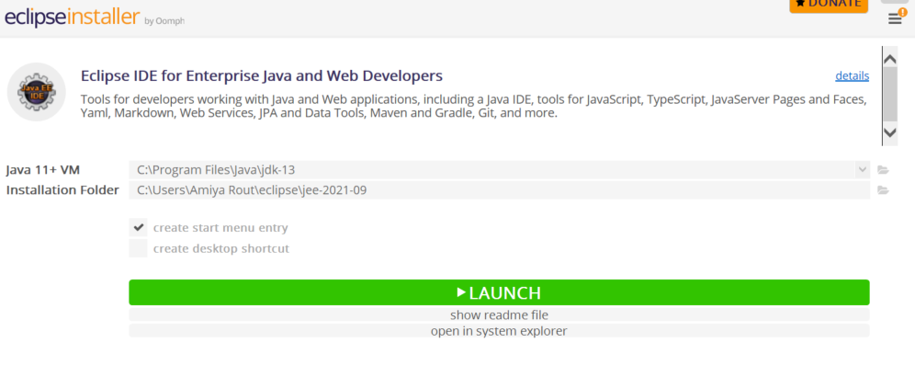

This is the Welcome screen after the successful installation of **Eclipse IDE for Enterprise Java and Web Development.**

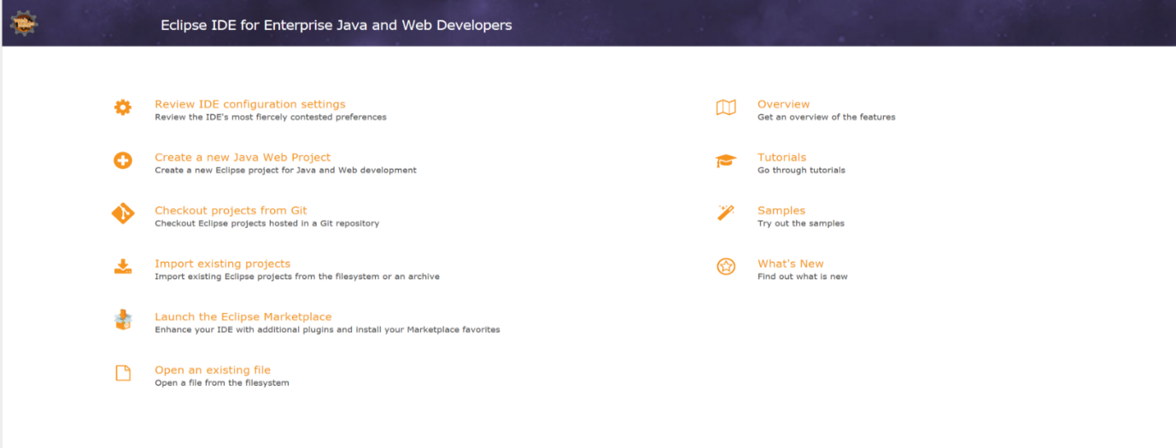

**Spring Tool Suite Download**

**Prerequisite:** Make sure you have installed Java Development Kit (JDK) version 17 or newer. To check simply go to the terminal and enter the below command to check if it is present or not.

javac -version in cmd and run.

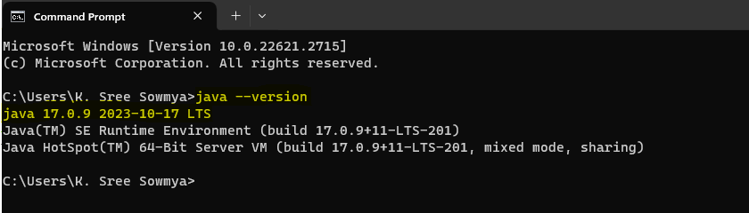

1. Download SpringToolSuite as per the operating system to the local machine.
2. Move the downloaded JAR file to the corresponding folder.
3. Unzip this JAR file and open the corresponding folder.
4. Click on the *SpringToolSuite4* Application file.
5. Select the directory representing workspace and press the *‘LAUNCH’* button.

**Step 1:** [Go to their website and in Spring Tools 4 for the Eclipse section](https://spring.io/tools) in order to download. choose your corresponding file according to your OS.

Here we are going with Windows operating systems so do we have chosen **Windows** option as seen in the below image.

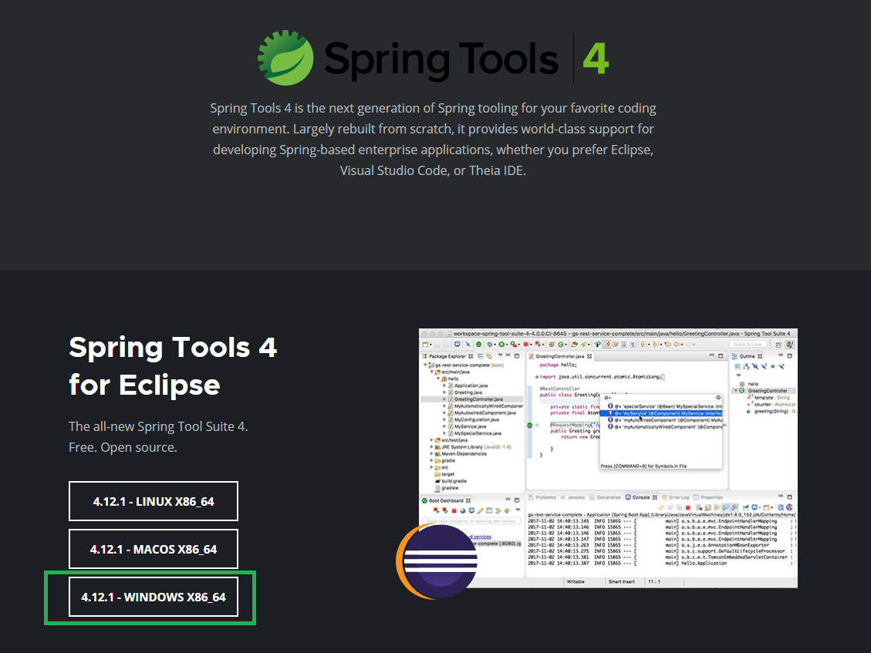

**Step 2:** After clicking on the button a **Jar file** will be downloaded to your local system. Now create a folder and move this Jar file to that folder. And double-click on that Jar file. A pop-up window will appear like below:

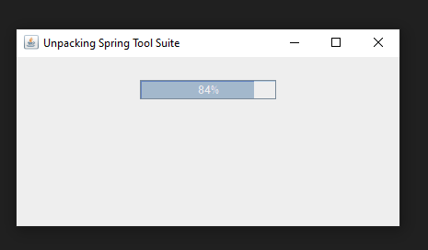

**Step 3:** After successfully Unpacking a new folder will create as shown in the below image:

Now open the folder,

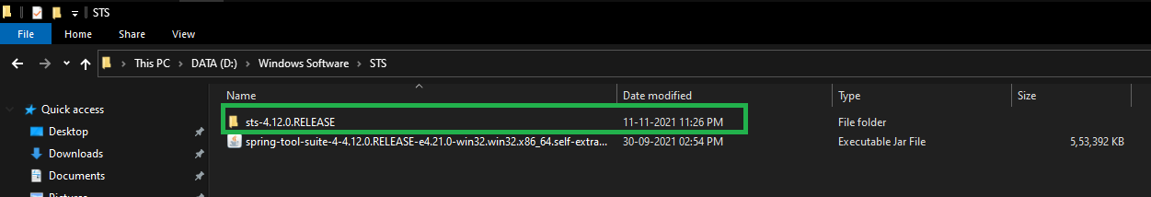

**Step 4:** In this folder now click on the **SpringToolSuite4** Application file as shown in the below image:

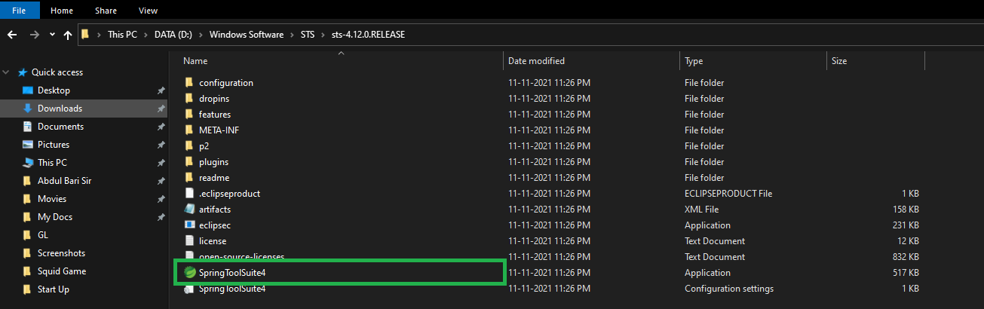

**Step 5:** Now select your directory as workspace by clicking on the **Browse** button and then click on the **Launch** button. And you are done.

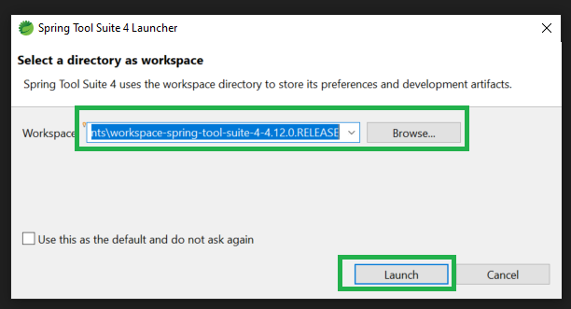

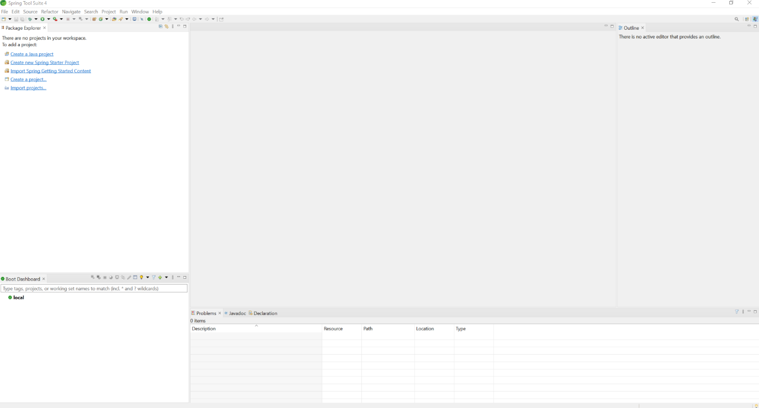

**Configuration of Apache Tomcat Server with Eclipse IDE**

**Note:** Download the latest version of eclipse IDE using[**this link**](https://www.eclipse.org/downloads/packages/release/2020-03/r/eclipse-ide-enterprise-java-developers-includes-incubating-components) and also configure the java environment. By default when Eclipse IDE is downloaded, it doesn’t come with Tomcat installed with it. Let us go over all detailed steps to configure Apache Tomcat in an Eclipse environment. **Step 1:** Download the latest version ( 9.0.34 ) of apache tomcat server from[this link](https://tomcat.apache.org/download-90.cgi) according to your platform. Also download version(10.1) of apache

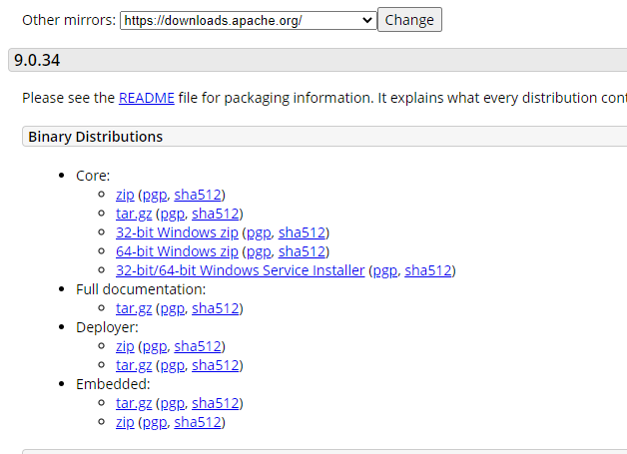

**Step 2:** Extract the files from zip folder. The structure of the folder should look like this:

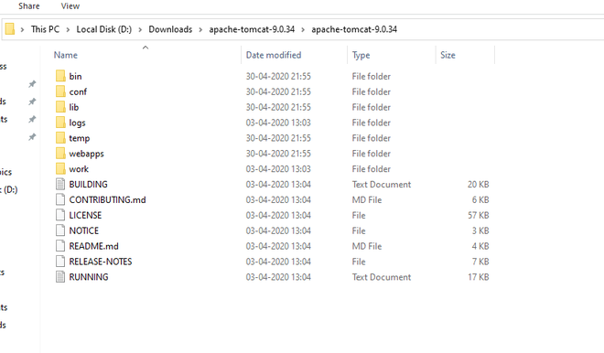

**Step 3:** Open Eclipse Java EE (Enterprise edition ) environment. Click on *Servers* tab at bottom. Click on *No servers are available. Click this to create server.*

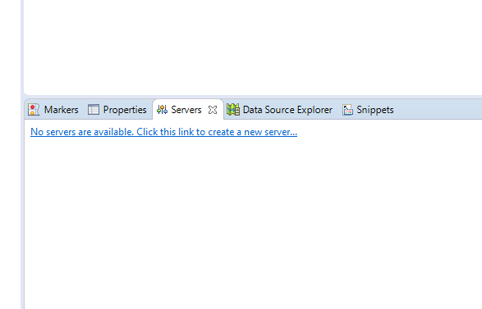

**Step 4:** A dialog box will appear. Select *Tomcat 9.0 server* folder. Click *Next.*

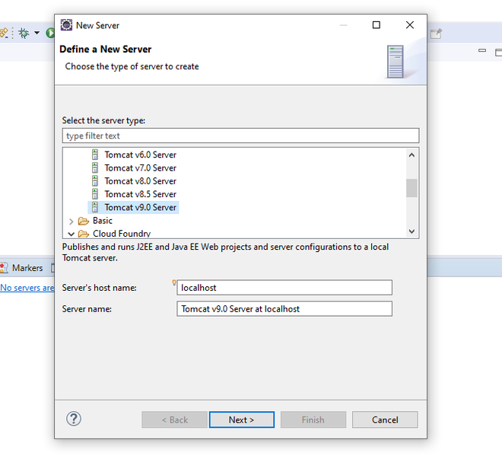

**Step 5:** Browse to *Apache Tomcat 9.0* folder select it. Click *Finish.*

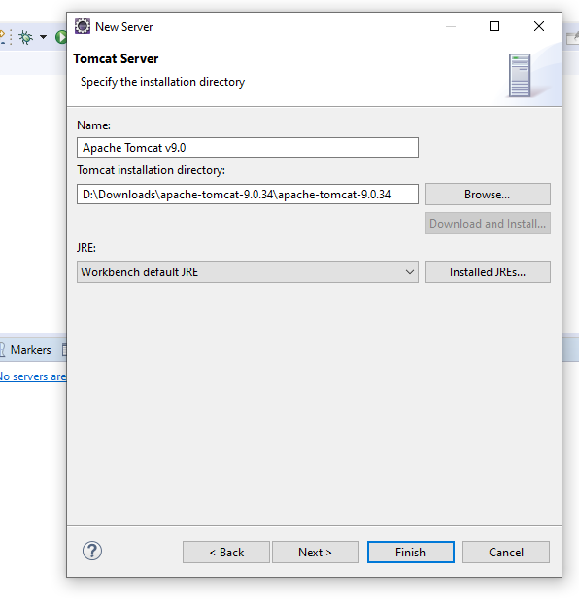

**Step 6:** You should see *Tomcat v9.0 Server at localhost [Stopped, Republish ]* under *Servers* tab. Double click on it and verify the HTTP ports. By default HTTP/1.1 port is 8080. If there is any application running on default port 8080 then change it to any other port.

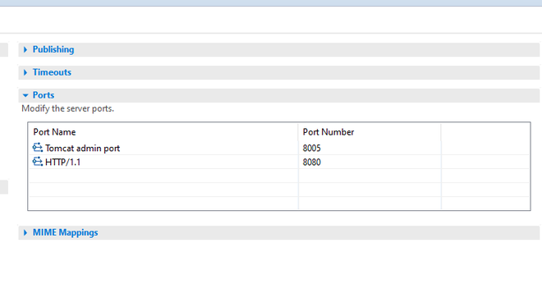

**Step 7:** Now right click on Server and click *Start.*

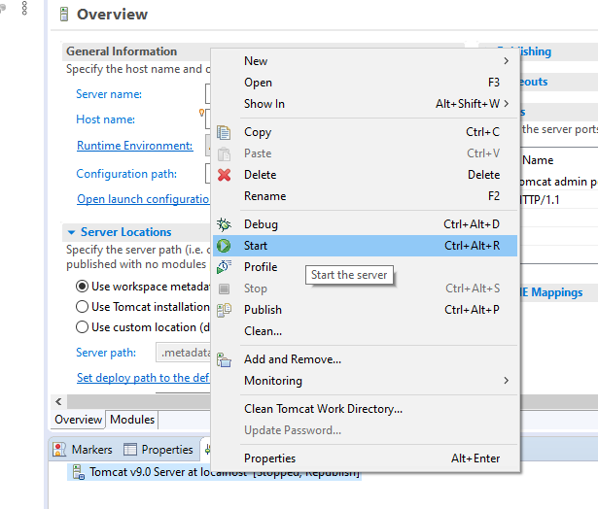

**Step 8:** The server will be started and shows the following *Tomcat v9.0 Server at localhost [ Started, Synchronized ].*

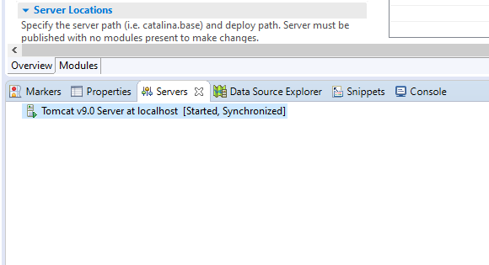

**Download and Install Maven**

Prerequisites

* A working Internet connection.
* A copy of Java installed and ready to use, with the JAVA_HOME environment variable set up.

**Step 1: Download Maven Zip File and Extract**

1. Visit the [Maven download page](https://maven.apache.org/download.cgi) and download the version of Maven you want to install. The Files section contains the archives of the latest version. Access earlier versions using the archives link in the Previous Releases section.

2. Click on the appropriate link to download the binary zip archive of the latest version of Maven. As of the time of writing this tutorial, that is version 3.9.5.

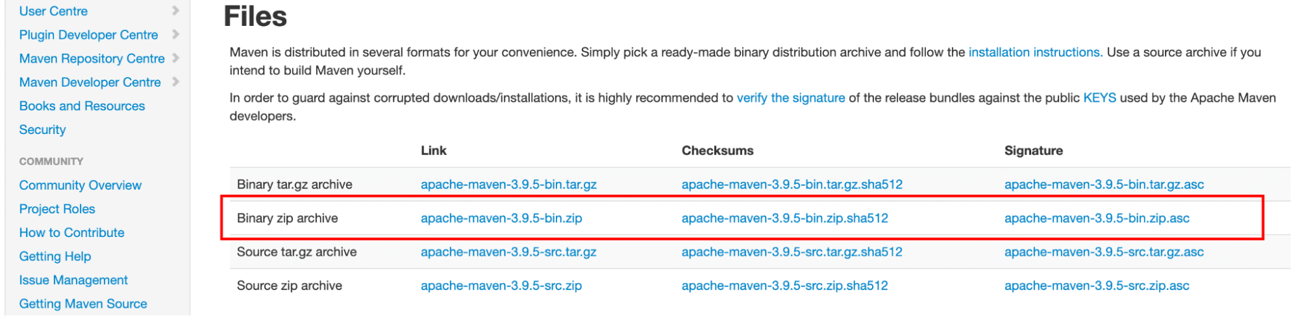

Once the download finishes, extract the downloaded Maven archive to a folder. We’ll extract the archive to C:\Program Files\apache-maven-3.9.5.

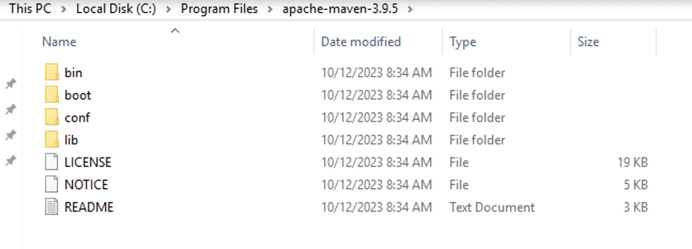

**Step #2: Set up the MAVEN_HOME System Variable**

The next step is to add the environment variable. For this, navigate to the Search Box to the right of the Start button and type in environment variables.

Select the option to Modify the system environment variables.

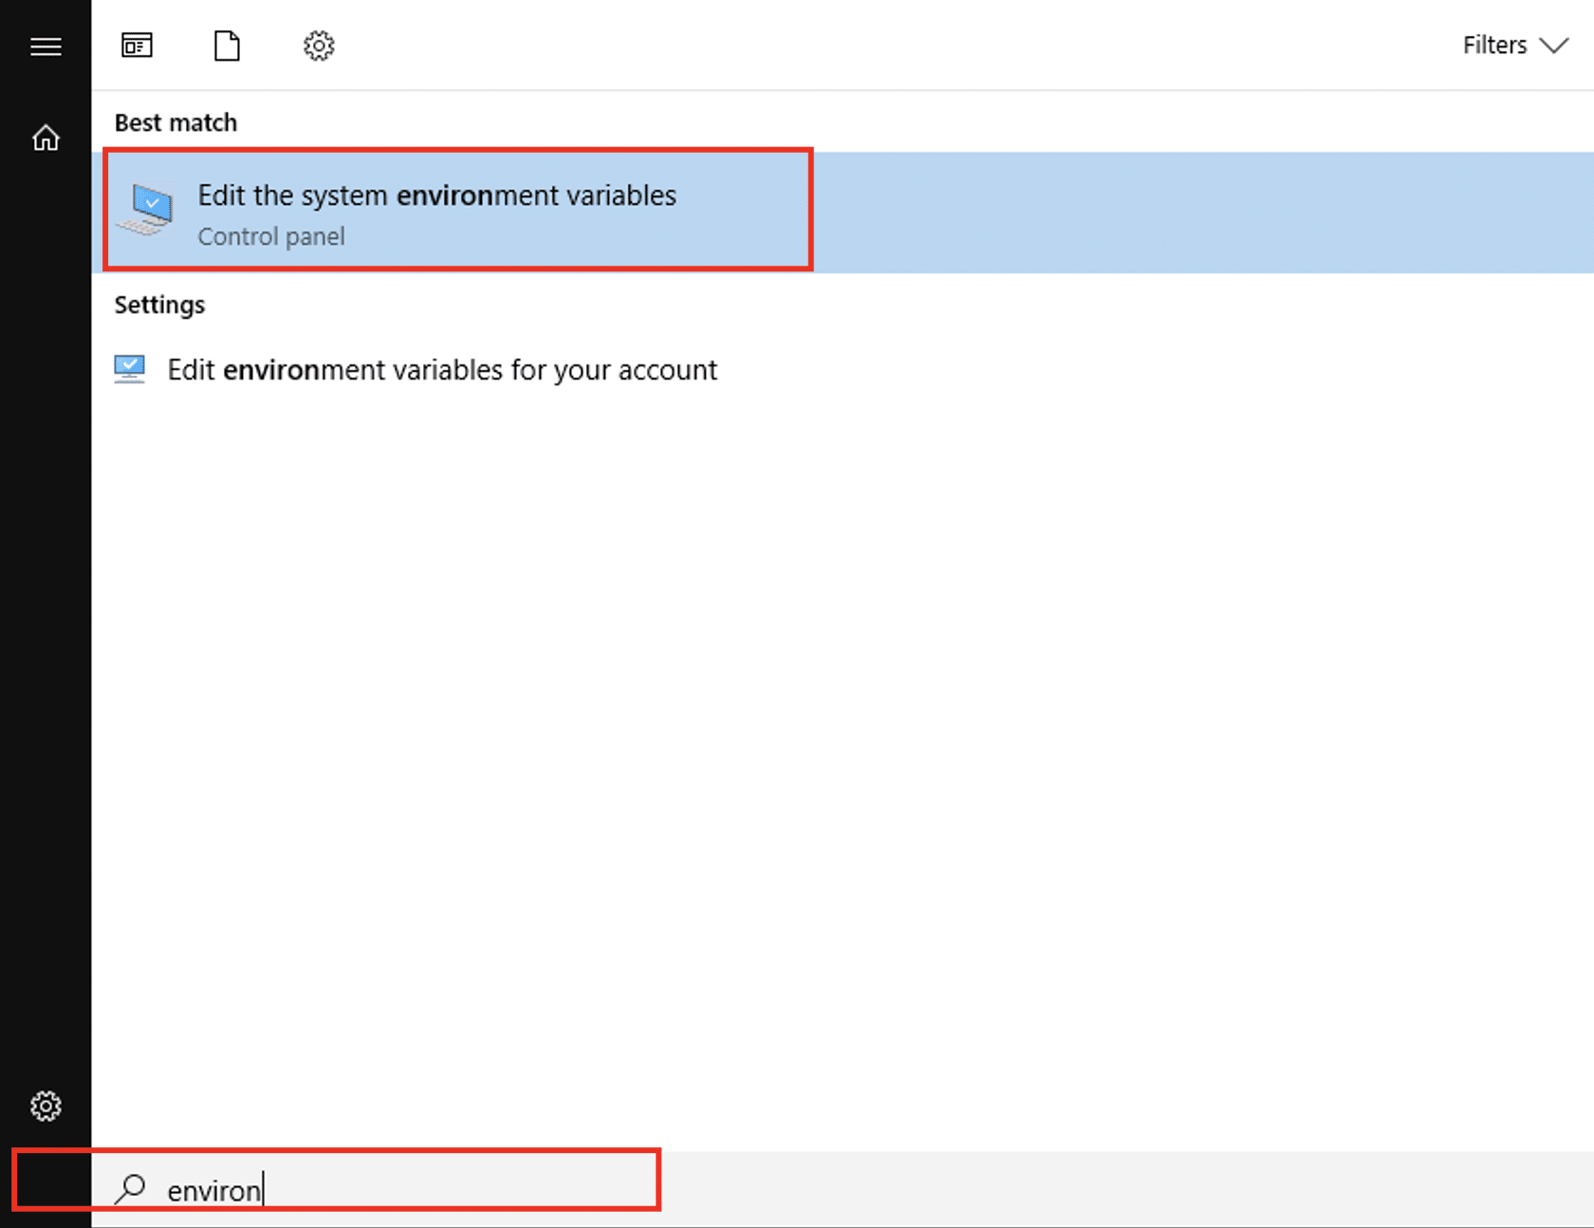

In the System Properties window, select **Environment Variables** from the **Advanced** section.

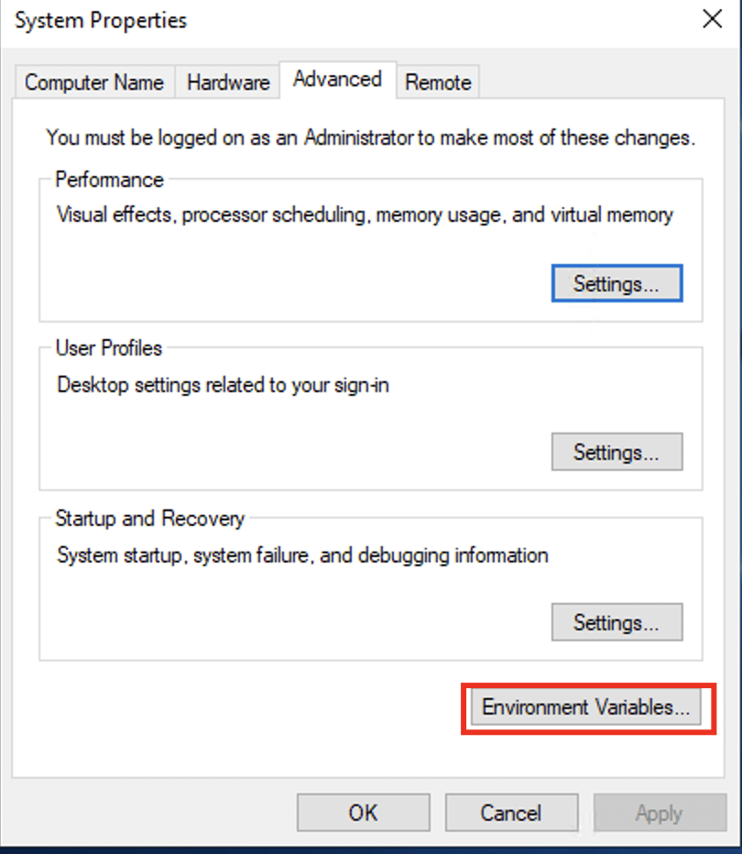

Select **New** in the **System variables** section to add a new system environment variable.

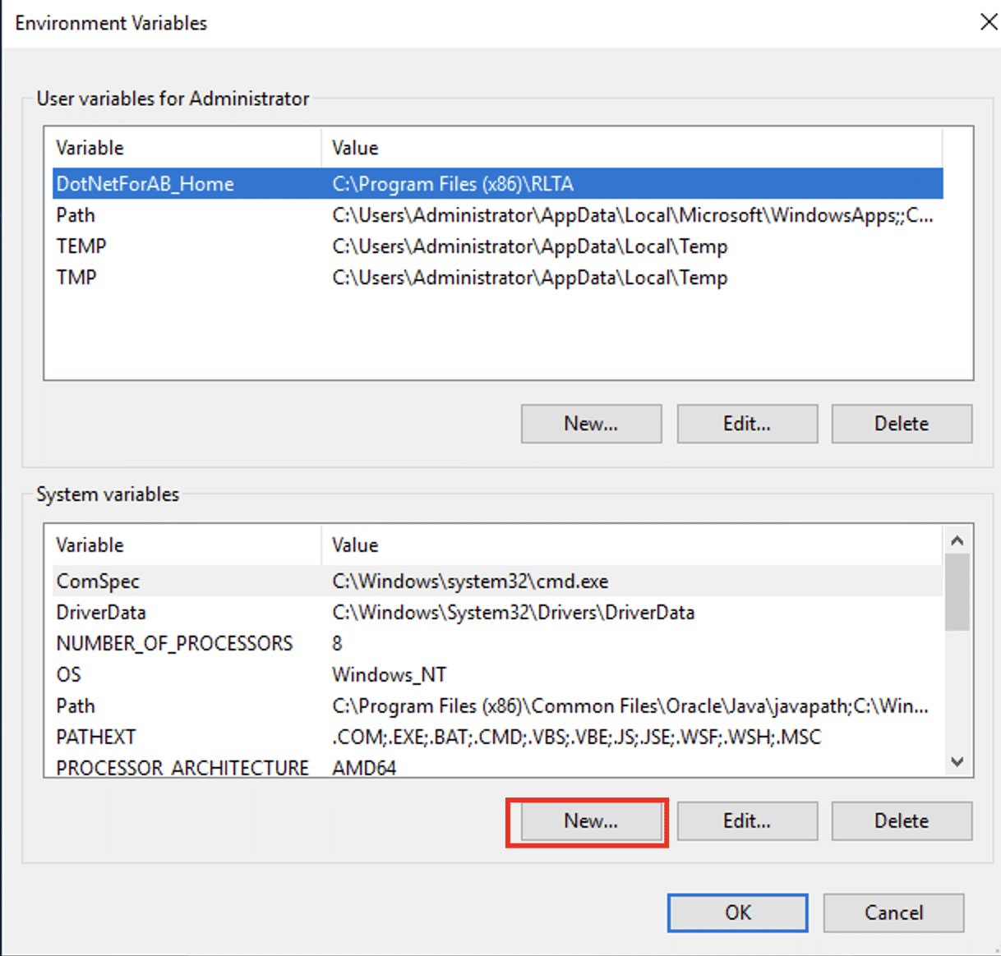

We’ll use MAVEN_HOME for the variable name and use the Maven’s folder path for the variable value. Click OK to save this new system variable.

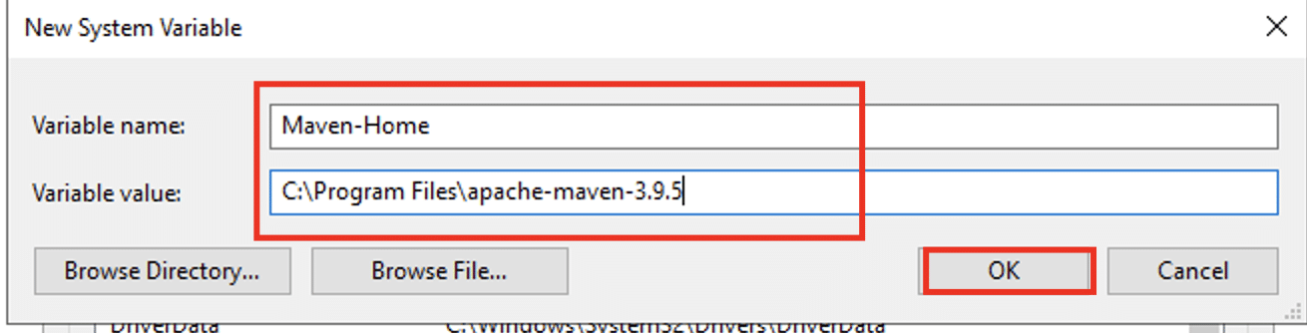

**Step #3: Insert MAVEN_HOME Folder into the PATH Variable.**

Choose the Path variable in the System variables section of the Environment Variables dialog box. Press the Edit button to modify this variable.

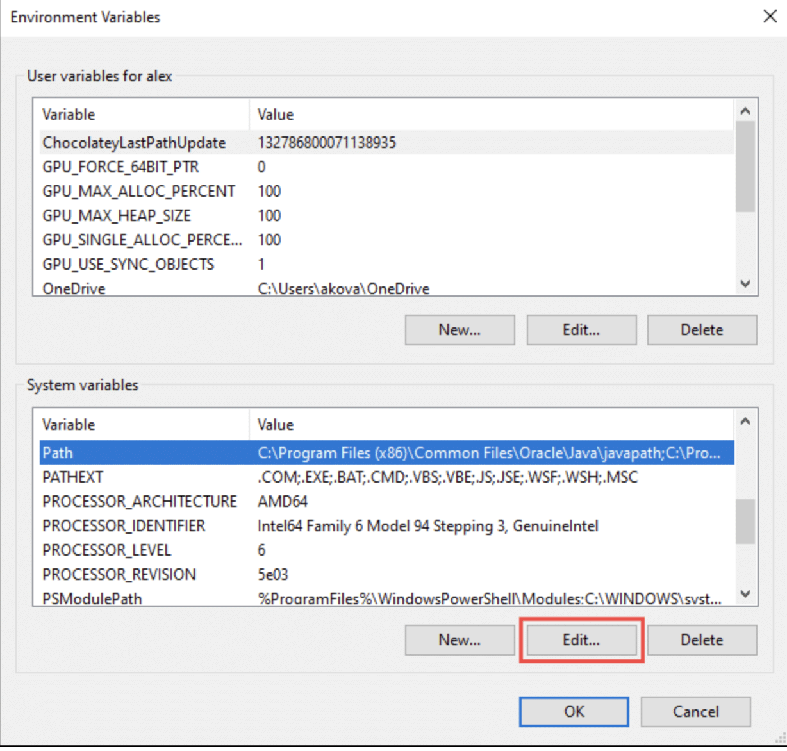

Tap the **New** button within the **Edit environment variable** dialog box.

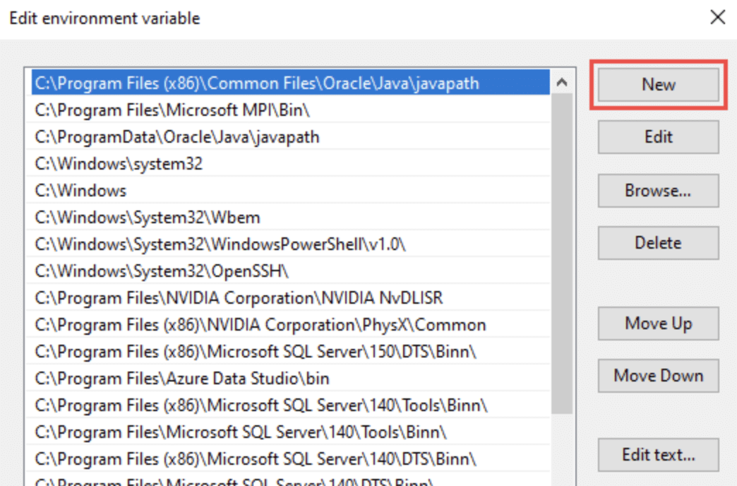

Enter **%MAVEN_HOME%\bin** into the field. Hit **OK** to store the changes.

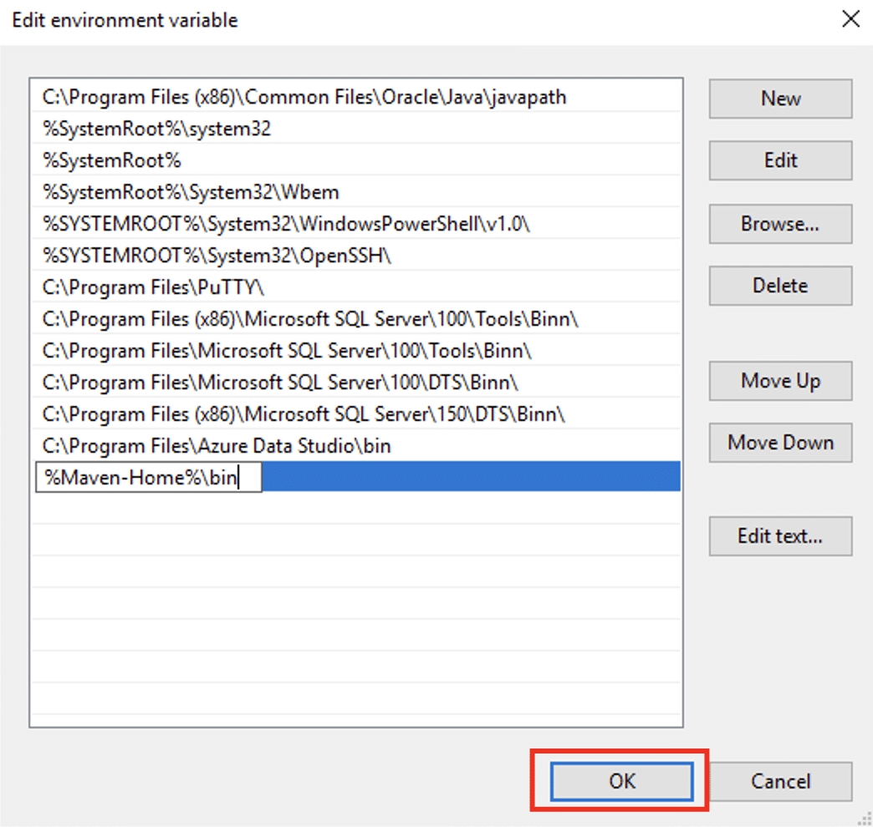

Now, hit **OK** to update the system variables and exit the dialog box.

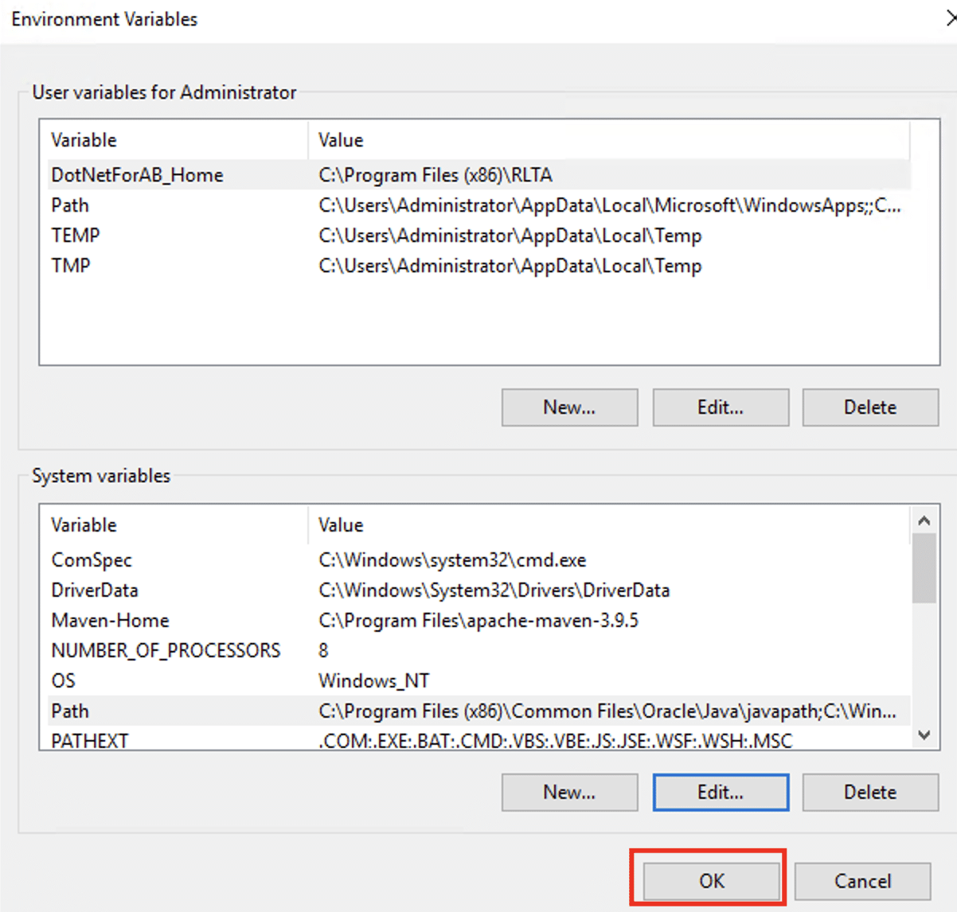

**Step #4: Confirm Maven Setup**

Once the installation process finishes, we’ll confirm that the Maven is correctly installed. For this, launch the Command Prompt by typing cmd in the Run window.

Enter the following command to authenticate the installation by getting the current Maven version:

C:> mvn -version

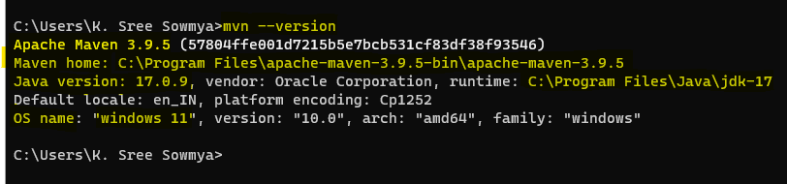

If you see the Maven version information, you have successfully installed Apache Maven on Windows.

**MySQL Installation Process:**

The installation process for MySQL is as follows:

1. Open the MySQL website on a browser. Click on the following link: [MySQL Downloads](https://www.mysql.com/downloads/).

2. Select the Downloads option.

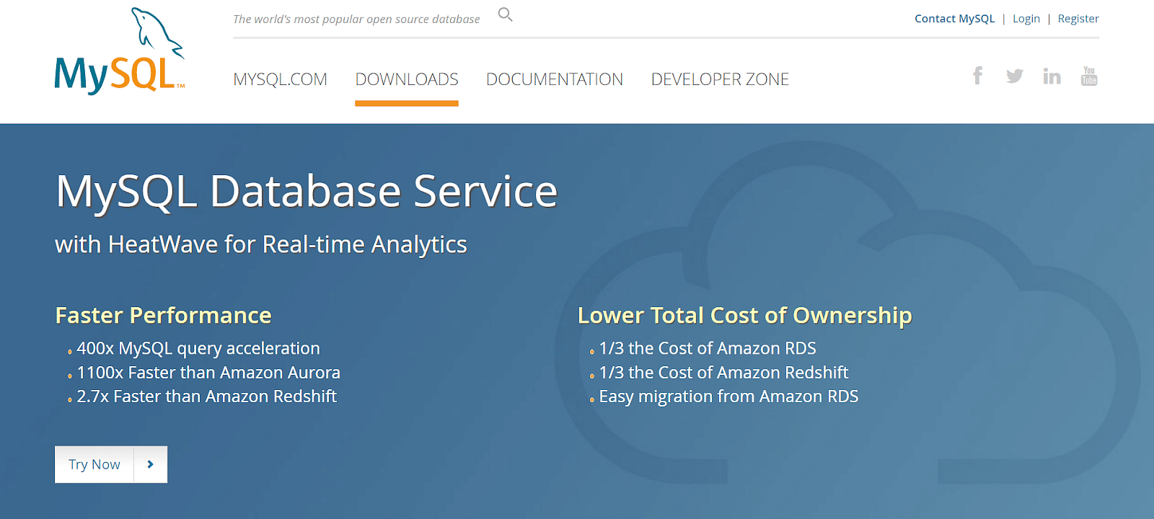

3. Select MySQL Installer for Windows.

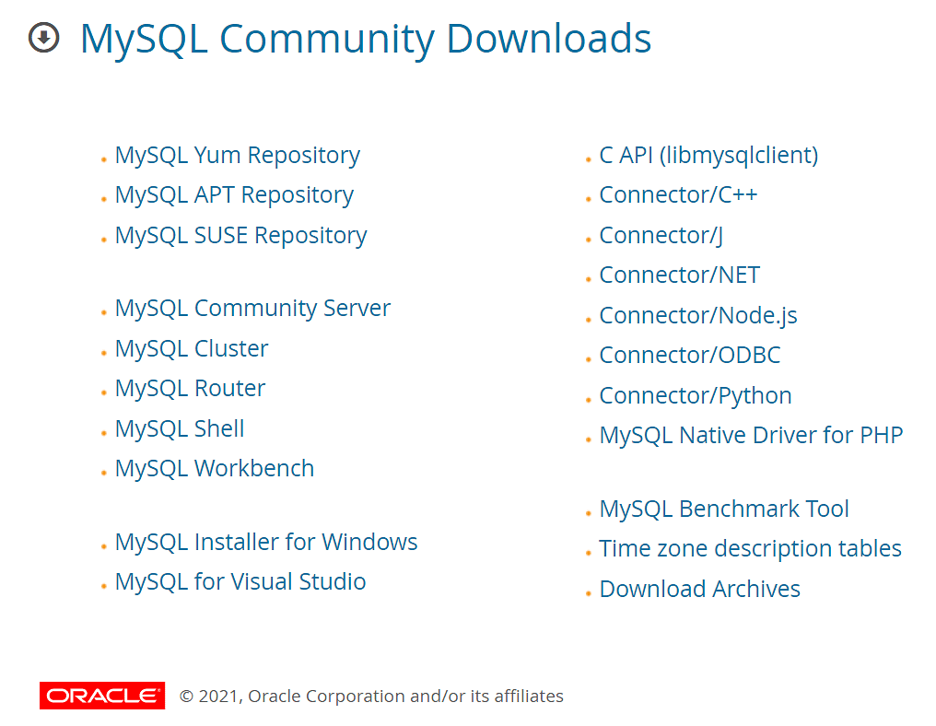

4. Choose the desired installer and click on download.

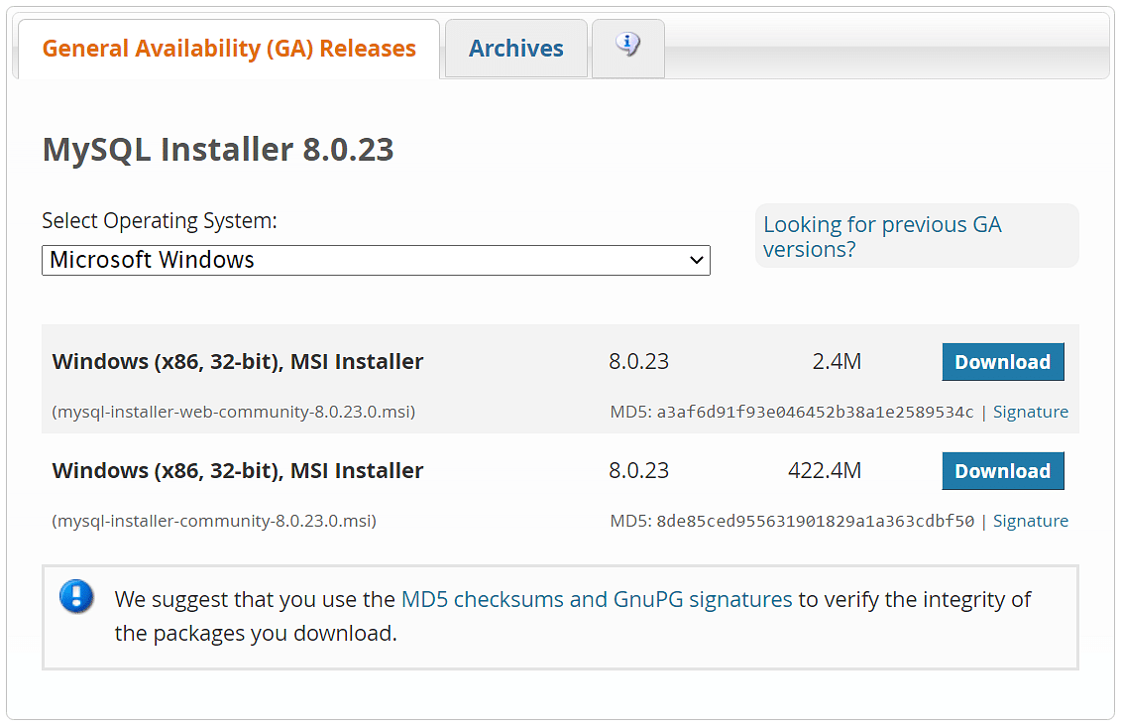

5. After the download, open the installer.

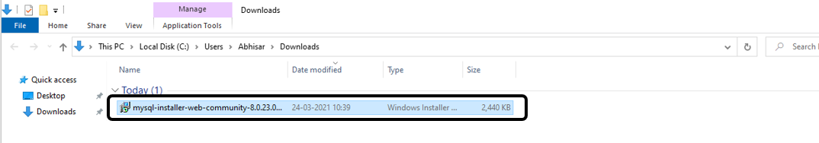

6. It will ask for permission; when it does, click Yes. The installer will then open. Now, it will ask to choose the setup type. Here, select Custom.

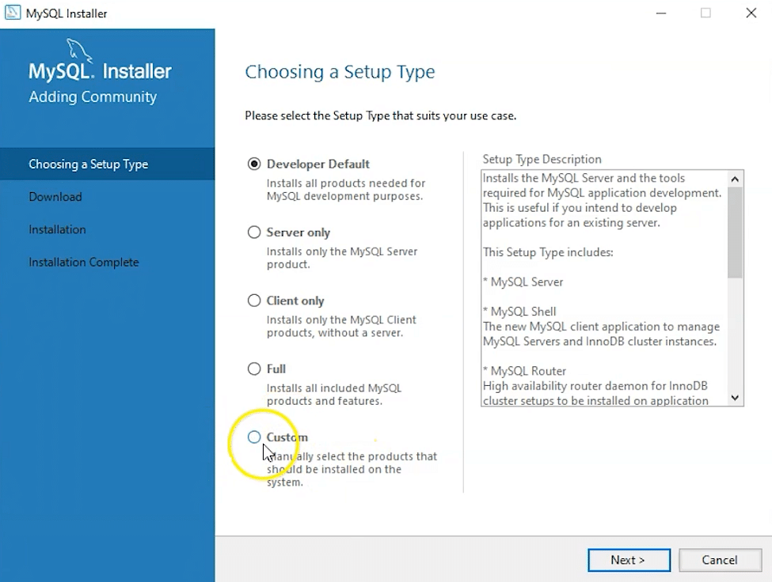

7. Click on Next. With this, you will install MySQL server, MySQL Workbench, and MySQL shell.

8. Open MySQL Servers, select the server you want to install, and move it to the  Products/Features to be installed window section. Now, expand Applications, choose MySQL Workbench and MySQL shell. Move both of them to ‘Products/Features to be installed’.

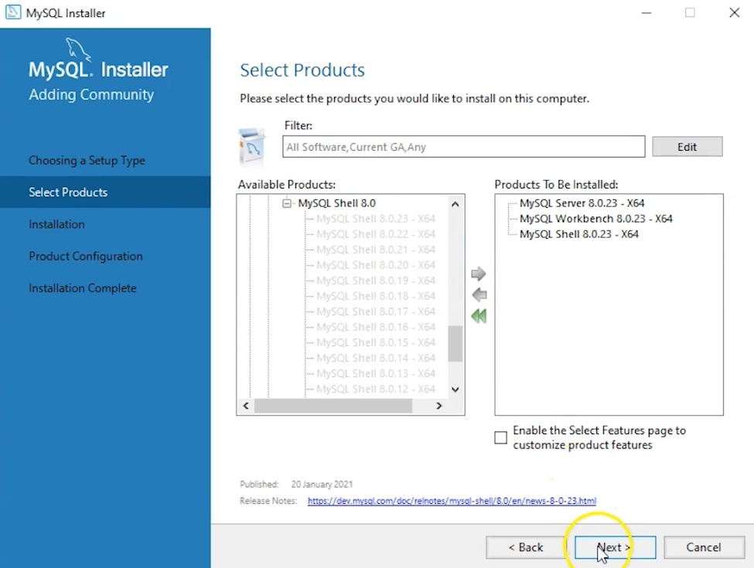

9. Click on the Next button. Now, click on the Execute button to download and install the MySQL server, MySQL Workbench, and the MySQL shell.

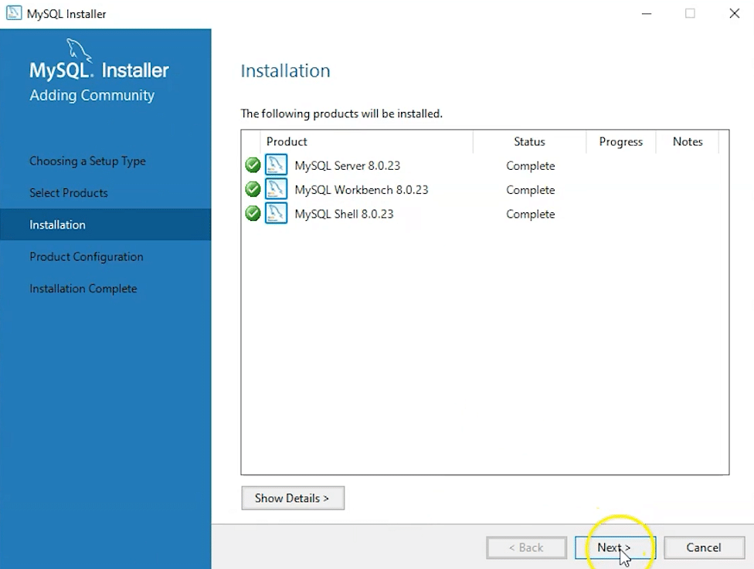

10. Once the product is ready to configure, click on Next. Under Type and Networking, go with the default settings and select Next.

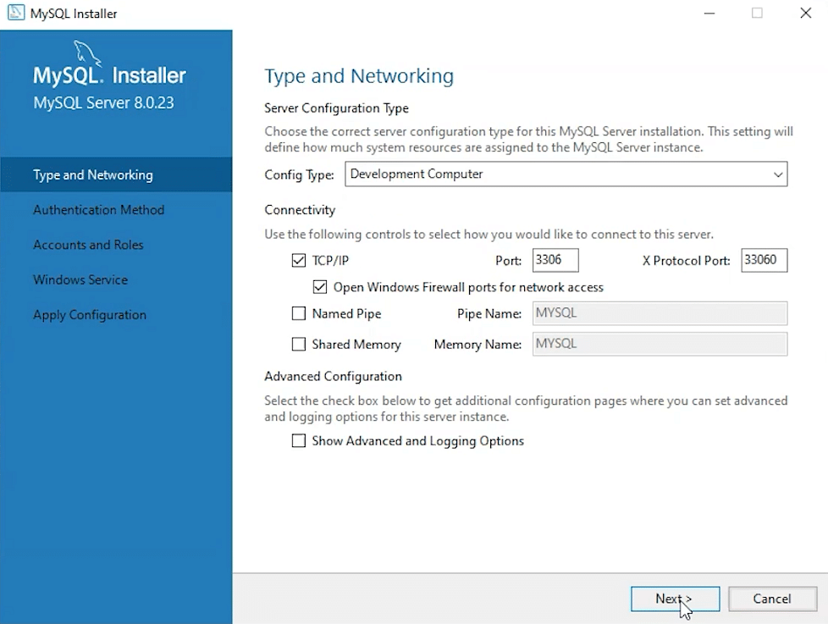

11. For authentication, use the recommended strong password encryption.

12. Set your MySQL Root password and click on next.

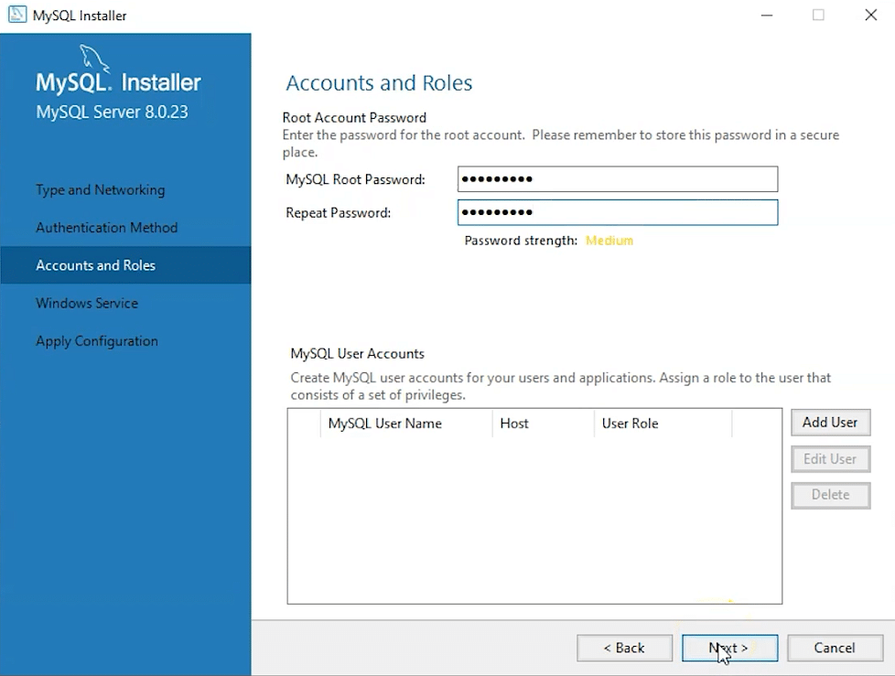

13. Go for the default windows service settings and under apply configuration, click on execute. Once the configuration is complete, click on finish.

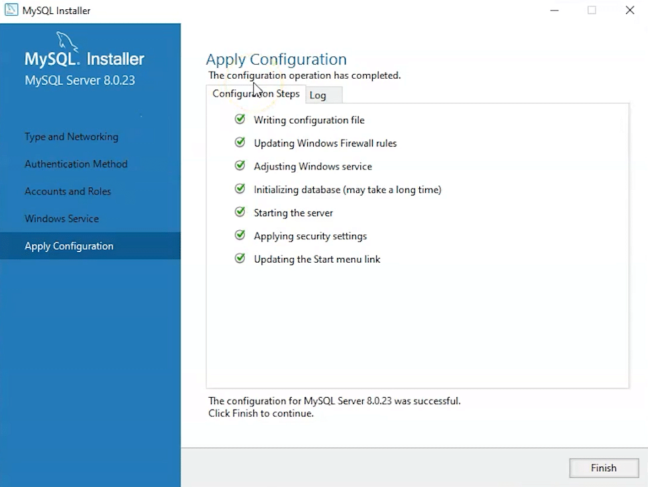

14. Complete the installation. This will now launch the MySQL Workbench and the MySQL Shell.

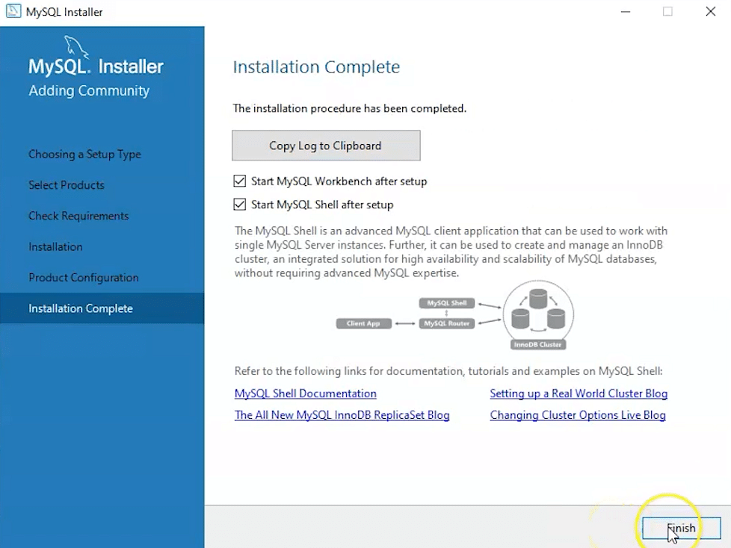

Once MySQL Workbench is installed, select the Local instance and enter the password.

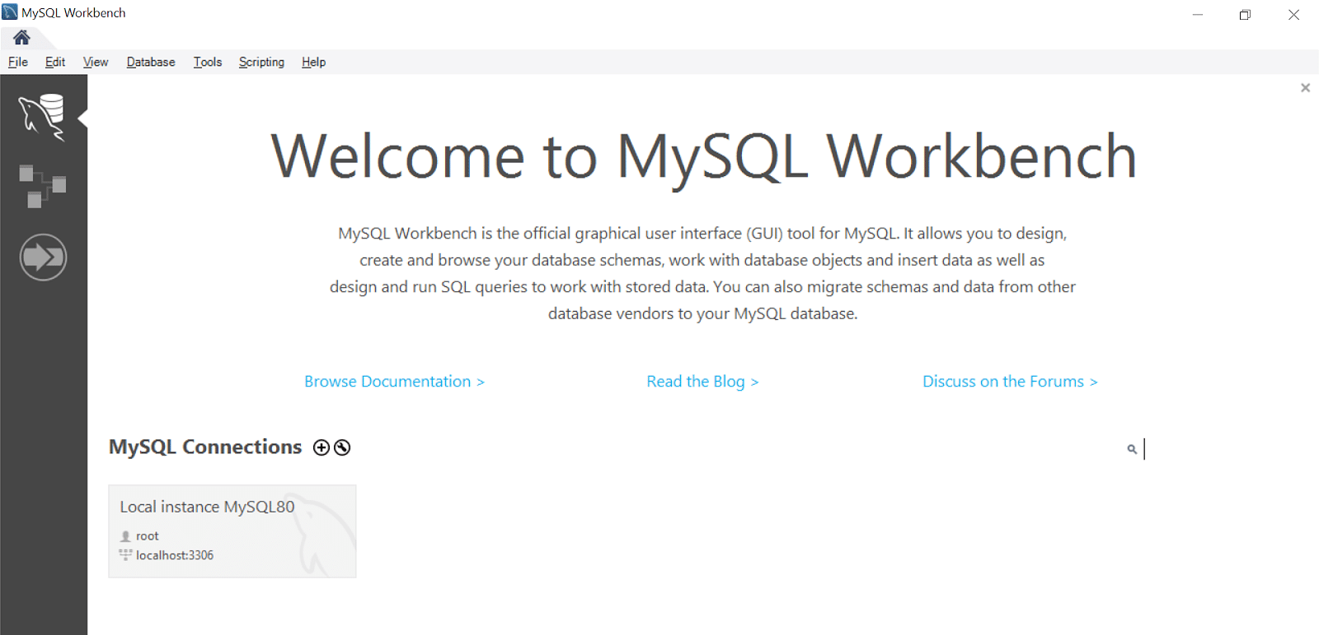

Now, you can use the MySQL query tab to write your SQL queries.

***How to Download Oracle 10g.***

### How to get Oracle 10g:

You can download Oracle 10g database from www.oracle.com. You must registered and create an account before you can download the software. The example in this document uses Oracle Database 10g Release 2 (10.2.0.1.0) for Microsoft Windows.

**How to uninstall Oracle database software:**

1. Uninstall all Oracle components using the Oracle Universal Installer (OUI).
2. Run regedit.exe and delete the HKEY_LOCAL_MACHINE/ SOFTWARE/ORACLE key. This contains registry entire for all Oracle products.
3. Delete any references to Oracle services left behind in the following part of the registry: HKEY LOCAL MACHINE/ SYSTEM/ CurrentControlsSet/ Services/Ora*. It should be pretty obvious which ones relate to Oracle
4. Reboot your machine.
5. Delete the C: \Oracle directory, or whatever directory is your Oracle_Base.
6. Delete the C:\Program Files \Oracle directory.
7. Empty the contents of your c:\temp directory.
8. Empty your recycle bin.

**Installing Oracle 10g database software :**

1. Insert Oracle CD , the autorun window opens automatically. If you are installing from network or hard disk, click setup.exe in the installation folder.
2. The Oracle Universal Installer (OUI) will run and display the Select Installation Method Window.

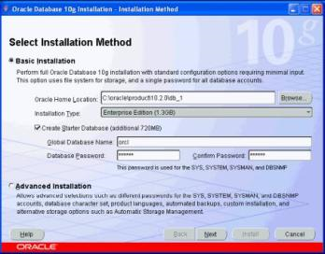

**3. Choose Basic Installation:**  
Select this option to quickly install Oracle Database 10g. This method requires minimal user input. It installs the software and optionally creates a general-purpose database based on the information you provide.  
For **basic installation**, you specify the following:  
**Oracle Home Location —**Enter the directory in which to install the Oracle Database 10g software. You must specify a new Oracle home directory for each new installation of Oracle Database 10g. Use the default value, which is :

c:\oracle\product\10.2.0\db_1

Installation Type — Select Enterprise Edition :  
If you have limited space, select standard edition. Personal edition installs the same software as the Enterprise Edition, but supports only a single-user development and deployment environment.  
Create Starter Database — Check this box to create a database during installation. Oracle recommends that you create a starter database for first Create Starter Database — time installations. Choose a Global Database Name, like cs157b, or just use the default value.  
Type a password. Don’t lose this password, since you will need it to connect to the database server.  
Click next .

The Product-Specific Prerequisite Checks window appears: Click next

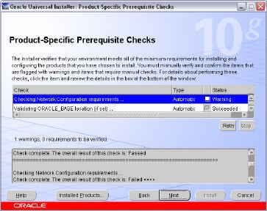

A summary screen appears showing information such as your global settings, space requirements and the new products to be installed. Click Install to start the installation.

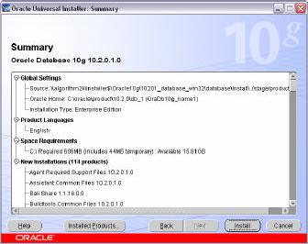

The Install window appears showing installation progress.

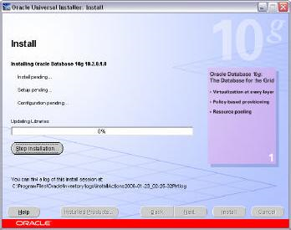

At the end of the installation phase, the **Configuration Assistants** window appears. This window lists the configuration assistants that are started automatically.  
If you are creating a database, then the **Database Configuration Assistant** starts automatically in a separate window.

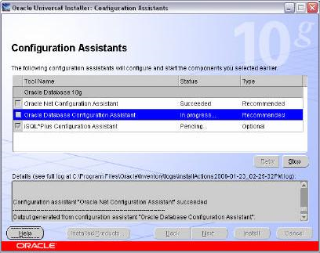

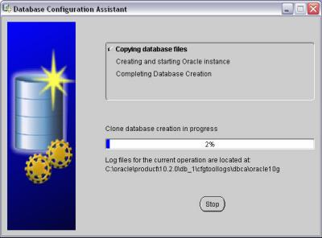

At the end of database creation, you are prompted to unlock user accounts to make the accounts accessible. The **SYS** and **SYSTEM** accounts are already unlocked. **Click OK** to bypass password management.

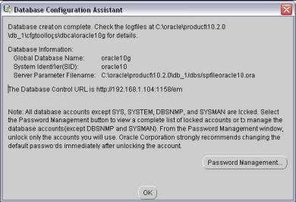

Note: Oracle 10g still keeps scott / tiger username and password (UID=scott, PWD=tiger) from the old version of oracle. In the old version of oracle, scott/tiger user ID is available by default, but not in oracle 10g. If you want to use scott /tiger account, you must unlock it by clicking “Password Management” at the last window.  
Password Management window will appear like the one shown below. Find the user name “Scott” and uncheck the “Lock Account?” column for the user name.

Your installation and database creation is now complete. The End of Installation window displays several important URLs, one of which is for Enterprise Manager.

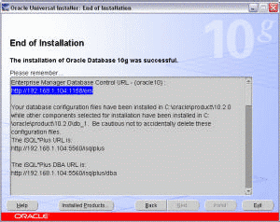

You can navigate to this URL in your browser and log in as the SYS user with the associated password, and connect as SYSDBA. You use Enterprise Manager to perform common database administrationtasks.  
**Note :** you can access Oracle Enterprise Manager using browser by typing the URL shown above in your browser. Instead of typing the IP address, you can also access the Enterprise Manager by typing **http://localhost:1158/em** or “**http://[yourComputerName]:1158/em**” or by clicking “**Start >> All Programs >> Oracle – [YourOracleHome_home1] >> Database Control – [yourOracleID]**” in Windows menu.  
By default, use user ID “**SYSTEM**”, with the password that you have chosen at the beginning of installation, to connect to database, SQLPlus, etc. If you want to use other user ID, you may create a new use .